### **Test 1**

### **Summary**

For this test, you’ll build a docker-compose app (phone book) that has a server-service in python/fastapi with a postgres database service and MUI react frontend service. The task is simple enough that you should write the code and avoid copy/pasting solutions from existing phone book examples (we will check for this).

### **React App**

Your goal is to create a simple form at the top that allows the user to enter in a first name, last name, and phone number and there should be a submit button. Once the submit button is pressed, the information should be displayed in a list below (automatically sorted by last name) along with all the previous information that was entered. This way the application can function as a simple phone book. When your application loads, the input fields (not the phone book list) should be pre-populated with at least the following value:

First name = Omic

Last name = Rocks

Phone = 5558675309

You should use React + MUI (https://v4.mui.com/) for your UI. A basic app might look like the image below. Yours should look better.

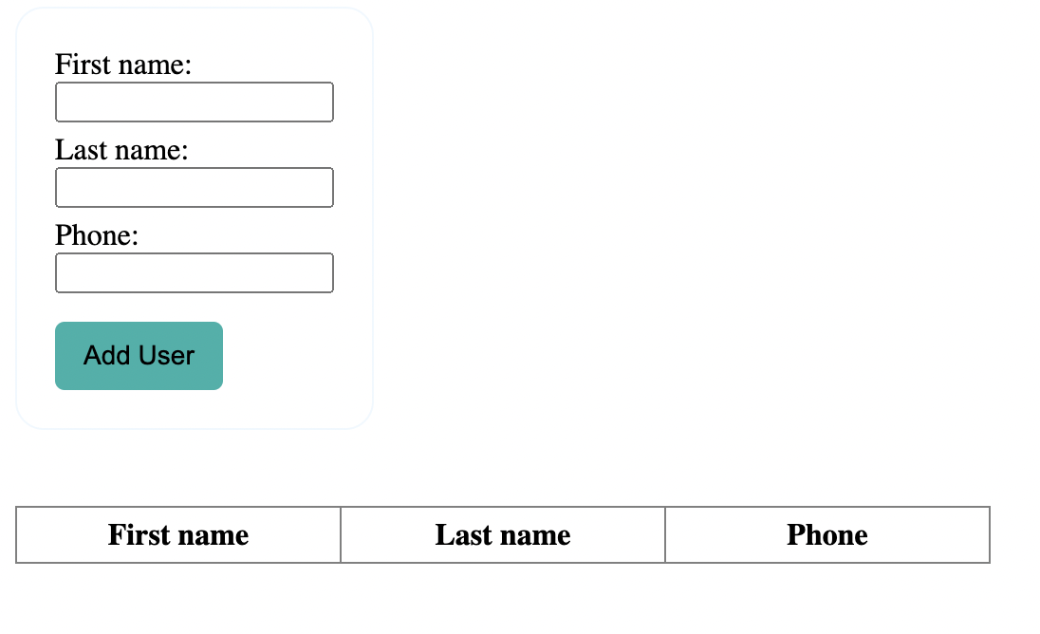

**Database**

Create a simple postgres database and service to store the contact information.

**Integration**

Build your server-service in python + FastAPI, using sqlalchemy for database abstraction.

**Deployment**

You’ll deploy via docker. Build your phone book app using docker-compose.

**Test 2**

### **Summary**

You will create a model to predict cell yields from blood donors.

1. Create a jupyter notebook that profiles the sample dataset provided (apheresis-dummy-data) and constructs a machine learning model to predict Day0CD34Yield values. Include relevant model statistics such as AUROC values.
2. Explain your choice of model construction based on the provided data and provide conclusions about the data set, key variables, and recommendations on how to improve the performance of your model in the future.
3. Assume you can request additional information about the blood donors to improve your model performance. What specific data would you ask for in order to improve your model the most?